SALES INSIGHTS OF A COMPANY

**Allamsetti Devisri**

**B.Tech (CSE), Gayatri Vidya Parishad College of Engineering (Autonomous), Andhrapradesh, India**

**Abstract:**

Insight based selling is an advanced-level skill where sales professionals connect their capabilities to a customer’s business issues by identifying blind spots in the customer’s strategy to create added value. The strategic use of insights at the right time in the right way can truly help sales professionals differentiate themselves.

In this project I am going to build a dashboard using power bi through which we can get the data insights for a company which will give good feedback such that it can go in a profit direction. With the help of this data insights we can make data-driven decisions and these decisions will help in increasing the sales. I mainly used the AIMS Grid, a Project Management Tool. SQL workbench to check the data and then I used the power bi tool and load the data from the SQL work bench and then we use the measures to make them into creative dashboards and these dashboards are used in the presentation to make the company to take data driven decisions.

**Keywords :** AIMS Grid, SQL Workbench, Power bi, Dashboards

**Introduction:**

Firstly, we take the data set of A company and go through the tables that are there in the database i.e., Customers, date, Markets, Products and Transactions tables. and have a overlook into that so that we can have a good picture of what are the tables that we are going to do, We load the data set that is provided by the company and load that database manually in the MySQL workbench then by using the commands we go across the tables that are there in the database.

Secondly, we connect the power bi tool with the MySQL workbench with the login details and use the name of the database and load that in the power bi. After loading the data, we clean the data with the power query editor which is obtained when we click on the transform the data button then we clean the data using the keywords and we also look at the redundant data. after doing all the cleaning and wrangling of the data we go to the next step that is the graphical representation of the data.

Next, we use the measures to create the axis in which the graph will be depending, then we edit the axis by dragging the table names to the legend blank and we use different types of graphs according to the requirement and then we plot those graphs and edit the x and y axis for the clear view of the data as we remove the names of the axis so that we can see the graph in a clear way.

After, creating dashboard we share that dashboard to the server using the work account and get the feedback from the stake holders and then improve the dashboard such that it becomes more efficient by adding the extra features to the dashboard, here we basically plotted the top customers and the products that are sold then how much is the revenue in the states and we also plotted the profit margin of the states and compared the previous year revenue with the present year revenue.

**Implementation of Methods:**

**Step-1 : AIMS Grid:**

AIMS grid is a very useful tool to improve **Project Management skills**for Project managers, Team Leaders etc. It helps to clarify a task and keep the process simple. AIMS grid presents a project in a very **concise** manner.

**Purpose**

**Stakeholders**

To unlock sales Insights

that are not visible

before sales team for decision

support & automate them

to reduce manual

time spent in data gathering

* Sales Director
* Marketing Team
* Customer Service Team
* Data & Analytics Team
* IT

Purpose

**Purpose**

**Success Criteria**

**End Result**

An automated dashboard providing quick & latest sales insights in order to support data-driven decision making

* Dashboard(s) uncovering sales order insights with least data available
* Sales Analyst stop data gathering Manually in order to save 20% of their business time.

**Step-2 : My SQL Workbench:**

Before going to the main project, we need to load the data into the MYSQL server workbench and look for the data and for the exploration, firstly we need to load the data for that Go to Server -> Data Import -> click on Import from Self-Contained File -> Browse for the dataset location -> click on Start Import.

When we use the SQL codes, we get the following data:

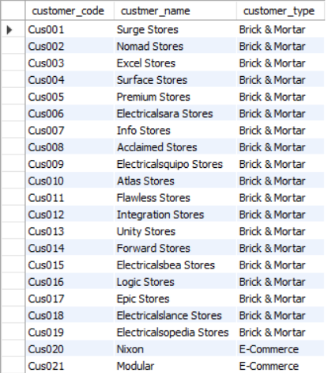SELECT * FROM sales.customers;

SELECT * FROM sales.transactions;

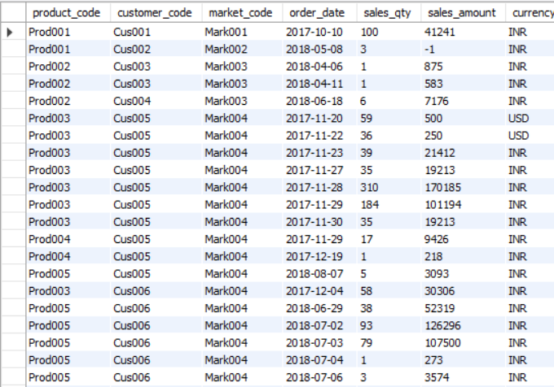

SELECT * FROM sales.products;

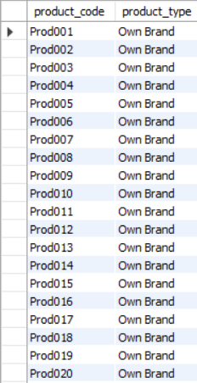

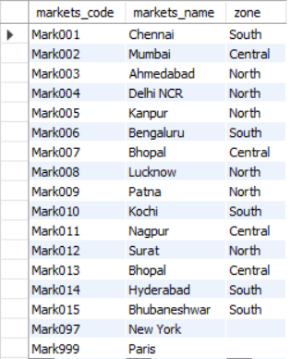SELECT * FROM sales.markets;

SELECT count(*) FROM sales.transactions;



SELECT * FROM sales.transactions WHERE market_code=”Mark001”;

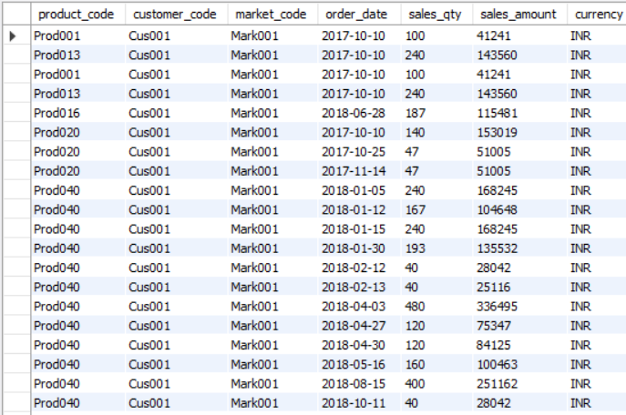

SELECT * FROM sales.transactions WHERE currency=”USD”;

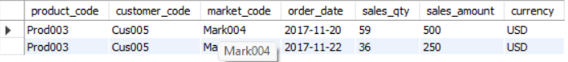

SELECT sales.transactions.*,sales.date.* FROM sales.transactions INNER JOIN sales.date ON sales.transactions.order_date=sales.date.date

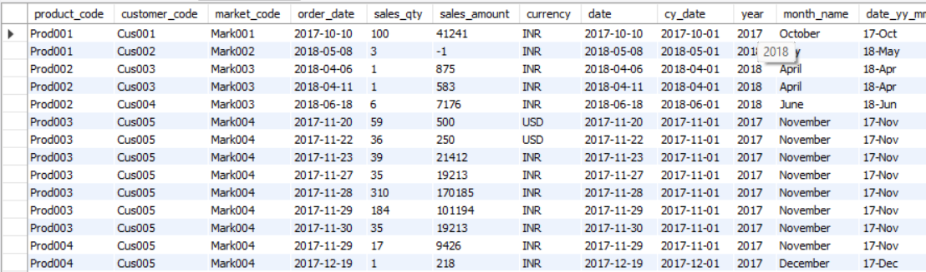

**Step-3 : Microsoft PowerBI:**

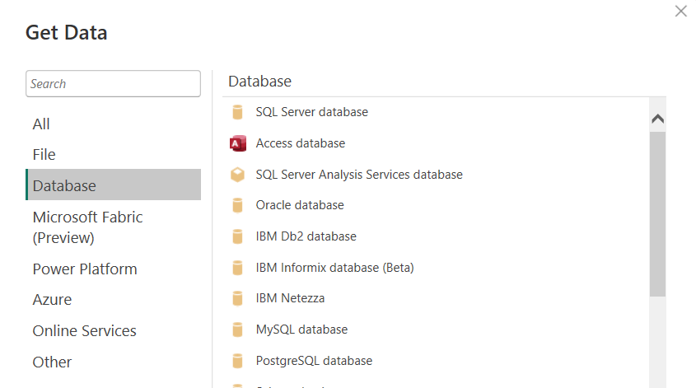After some analysis in the My SQL Workbench we will try to load the data from “My SQL Database”.

My SQL database

Loading can be done in this way:

Enter Server name as localhost and Database name as sales.

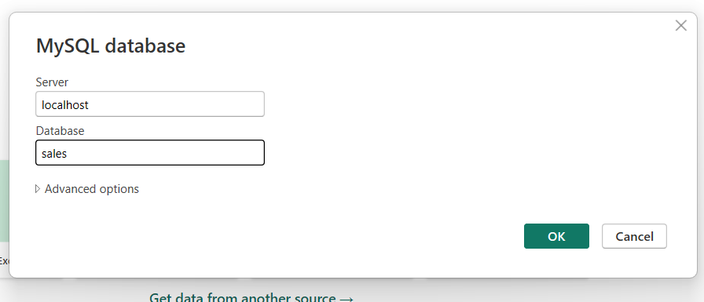

Select all the tables in the sales database and click on “Load”.

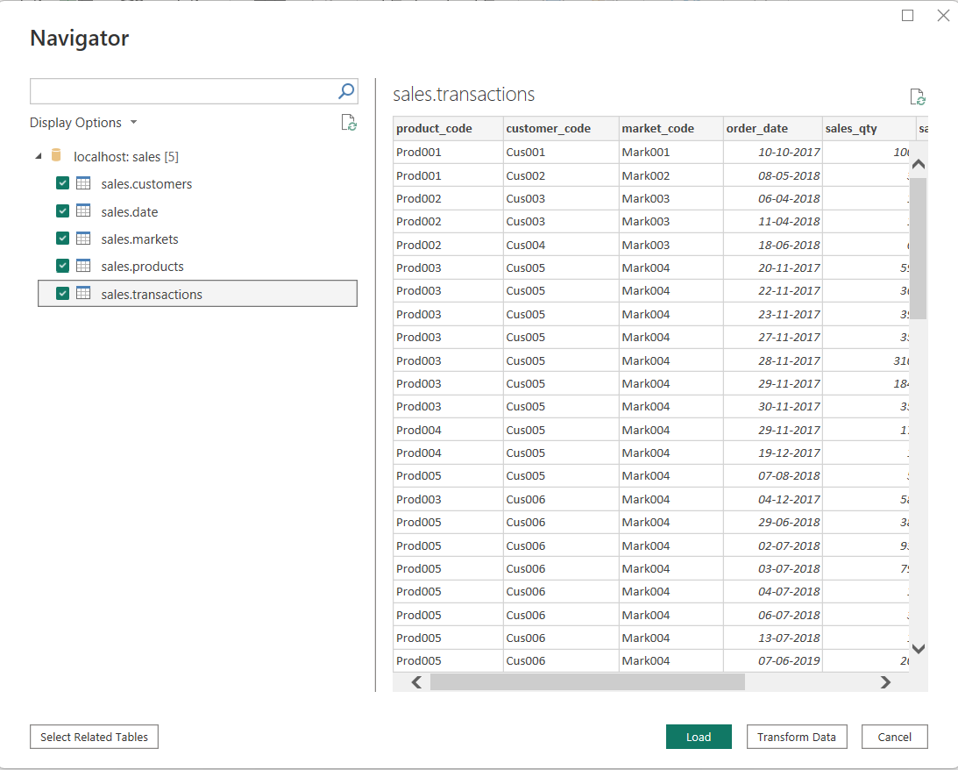

The process takes place as:

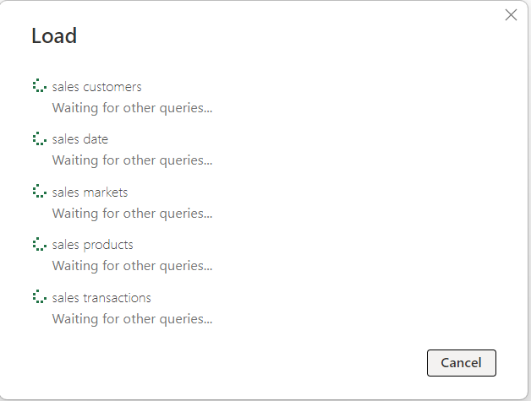

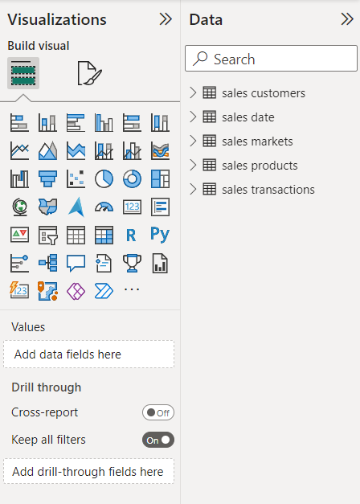

Required tables are loaded

You can observe there is a tool bar on the left side

 Report view

Data view

Model view

Report view is used for visualization

Data view displays the data in tabular format

Model view displays the relationships between the tables present in the database.

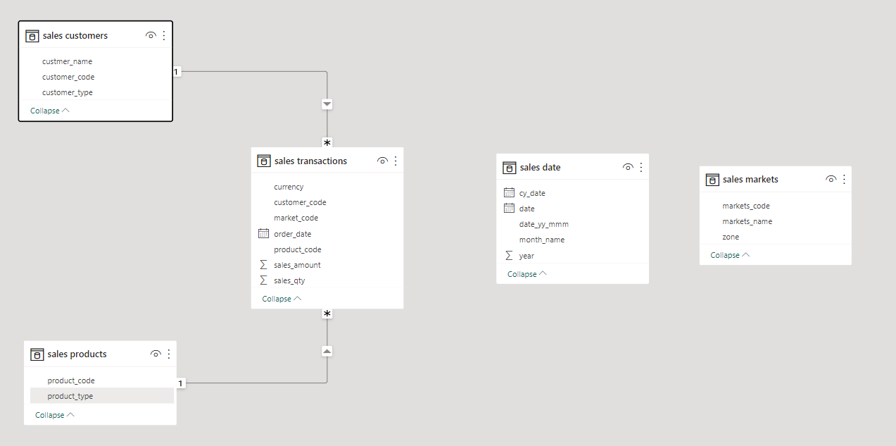

Model View

Now we have to transform the data. So In markets table we need to eliminate the cities which doesn’t reside in India.

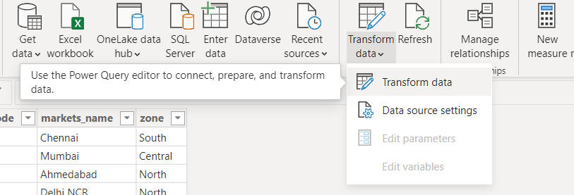After clicking on “Transform data” it opens a Power Query Editor where we perform ETL operations.

Now click on zone and does not select Blank values

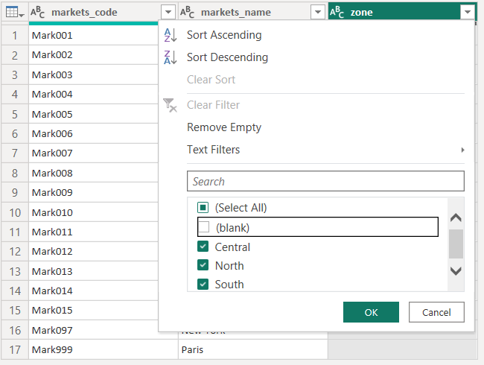

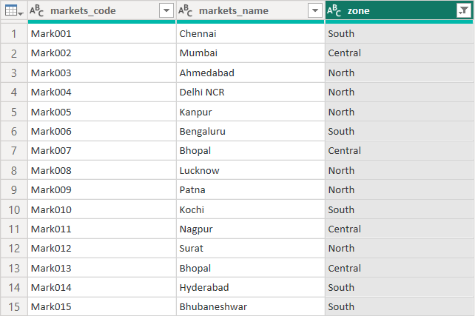Now the table displays as:

Here the records related to Paris and Newyork are eliminated.

When we are analyzing data in My SQL Workbench we had observed that in transactions table the sales_amount is in 0’s or negatives. So these values are not useful for our analysis because sales_amount cannot be less than or equal to 0.

SELECT * FROM sales.transaction WHERE sales_amount<=0;

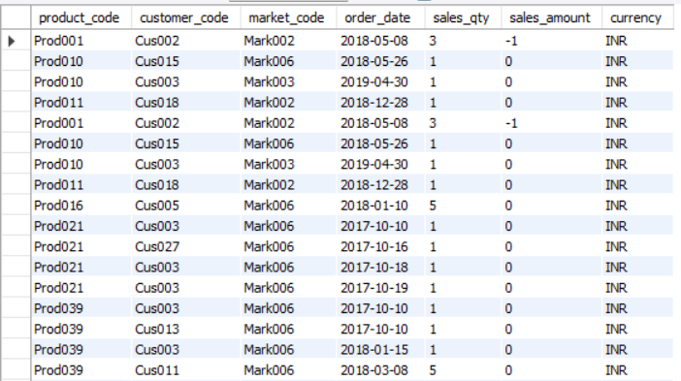

SELECT count(*) FROM sales.transactions WHERE sales_amount<=0;



So, we need to filter these values using Power Query Editor.

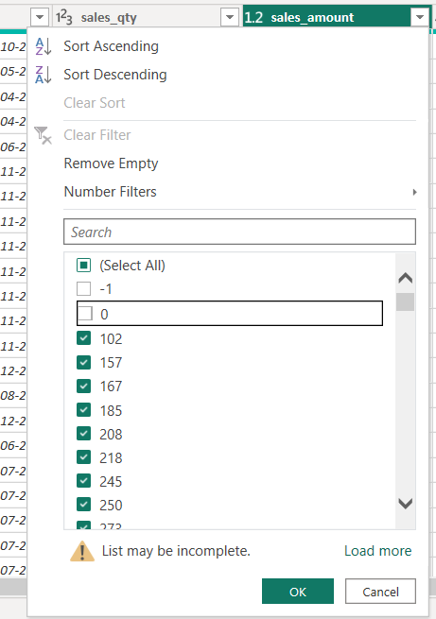

And one more Transformation in transactions table is to convert USD into INR.

For that we need to create a new column where all the values are stored in INR.

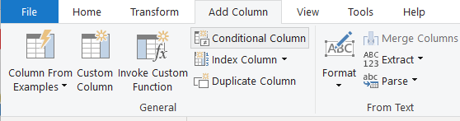

Click on “Conditional Column” and enter the required details:

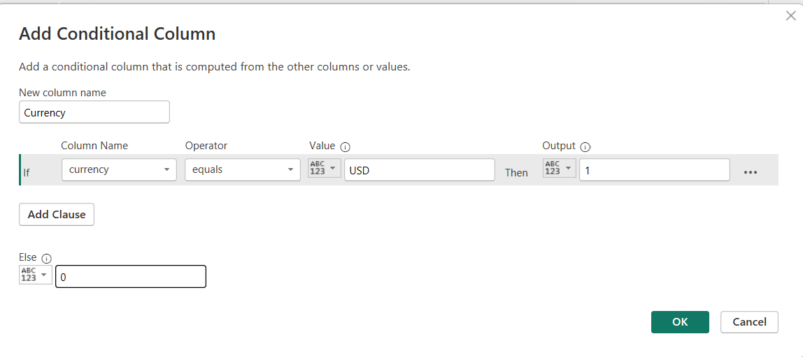

Syntax to convert USD to INR:

= Table.AddColumn(#"Filtered Rows", "normalize_sales_amount", each if [currency] = "USD" then [sales_amount]*75 else [sales_amount])

So now to apply these all transformations click on Close & Apply

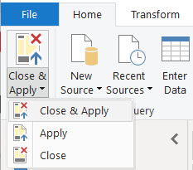

Now it will move into the Power BI Desktop.

Now again after doing some analysis in My SQL Workbench that we have identified there are some duplicate currency records.

So again we need to filter the transactions table by removing these unnecessary records which are not required for Analysis.

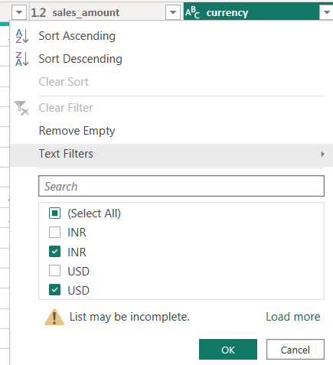

So Data cleaning has been completed. Now our aim is to build a powerful and an Interactive dashboard.

Final Dashboard:

